Directions: Login to Naviance Student and review your “careers I’m thinking about list.” Select two careers from your list that you are most interested in researching in further detail, or search for new career options using the career lookup tools. To complete the information below, click the name of your FIRST career choice to view its detailed profile (job description, knowledge and skills, tasks and activities, and wages). Also, explore Roadtrip Nation videos about leaders in this career field. Feel free to use outside resources as well.

Career Choice #1: ____________________________________________________________________________________________________________________________

Why did you choose to research this career?

How does this career relate to your passions, interests, and strengths?
Job Description

What qualifications, certifications, degrees, and/or education does this career require?

What is the average National Salary for this career? Average Michigan Salary?

What general skills are necessary for this career? (i.e. presentation skills, working on team, etc.)

Would you need to relocate? Where to?

List 2 Interesting Facts about this Career:
1.

2.
What does a “day in the life” of this career look like? (i.e. typical work hours, travel, etc.)

What are two potential courses you might take in High School that could help you gain skills for this career?
1.
2.
Career Research Project Graphic Organizer

Directions: Login to Naviance Student and review your “careers I’m thinking about list.” Select two careers from your list that you are most interested in researching in further detail, or search for new career options using the career lookup tools. To
complete the information below, click the name of your SECOND career choice to view its detailed profile (job description, knowledge and skills, tasks and activities, and wages). Also, explore Roadtrip Nation videos about leaders in this career field. Feel free to use outside resources as well.

Career Choice #2: ____________________________________________________________________________________________________________________________

Why did you choose to research this career?

How does this career relate to your passions, interests, and strengths?
Job Description

What qualifications, certifications, degrees, and/or education does this career require?

What is the average National Salary for this career? Average Michigan Salary?

What general skills are necessary for this career? (i.e. presentation skills, working on team, etc.)

Would you need to relocate? Where to?

What does a “day in the life” of this career look like? (i.e. typical work hours, travel, etc.)
List 2 Interesting Facts about this Career:
1.

2.

What are two potential courses you might take in High School that could help you gain skills for this career?
1.
2.
Career Research Project Graphic Organizer

Directions: Compare your two careers choices using the Venn Diagram below. Label each circle with the name of your career choice. In the center where the two circles overlap, write the ways in which your careers choices are the same. In the other portions of the two circles, write the ways in which your careers choices are different or unique from each other.
Unique details about career choice #1
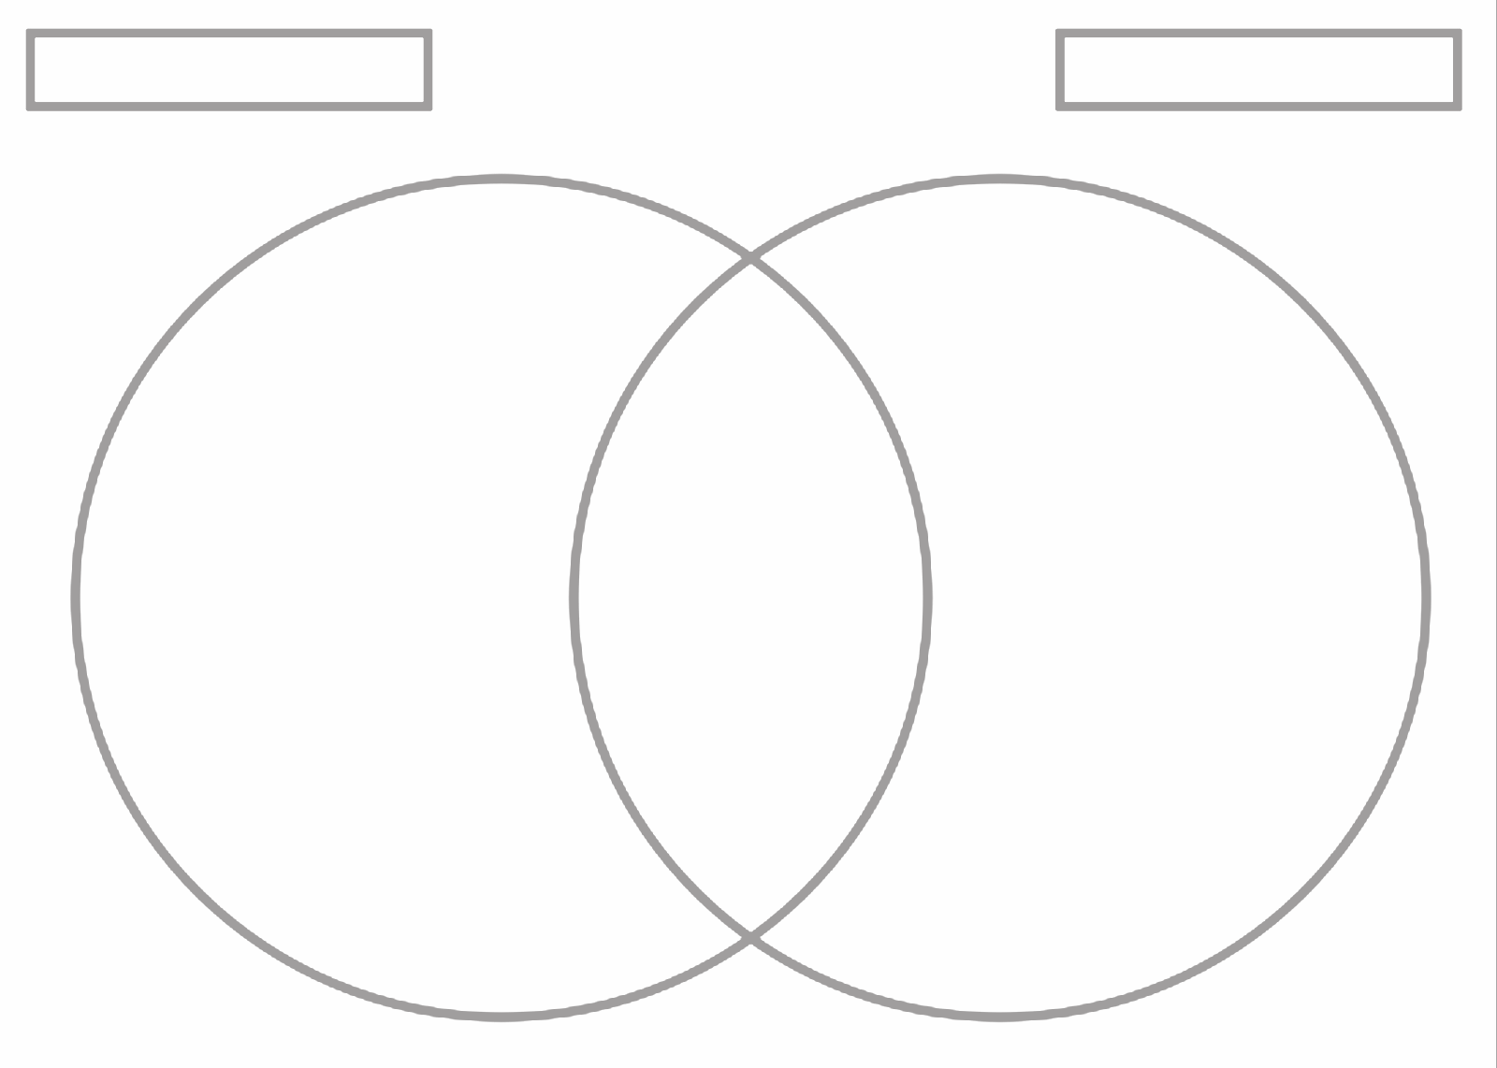
Unique details about career choice #2
Ways in which your two career choices are the similar
Unique details about career choice #1
name of career choice #2
Name of career choice #1

Reflection: Of the two careers you researched, which do you think would suit your interests, wants, and needs most? Why?

Out of the two careers I researched, ___________________________________________________________ would fit my future goals best because…

______________________________________________________________________________________
______________________________________________________________________________________
______________________________________________________________________________________
______________________________________________________________________________________
______________________________________________________________________________________
______________________________________________________________________________________
______________________________________________________________________________________
______________________________________________________________________________________
______________________________________________________________________________________
______________________________________________________________________________________

Linking your careers of interest to your course selection process: create a list of questions you would want to ask your counselor or school support network to help you select classes that will help you obtain skills that tie to your career(s) of interest:

Example Questions to Consider: Are there any CTE courses you would suggest based on my career(s) of interest? What classes would help me gain presentation skills? Is there a program or pathway in High School that would help me become a (career name here)?

1.

2.

3.

4.

5.

